20. Write a C program for ECB mode, if there is an error in a block of the transmitted ciphertext, only
the corresponding plaintext block is affected. However, in the CBC mode, this error propagates. For
example, an error in the transmitted C1 obviously corrupts P1 and P2.
a. Are any blocks beyond P2 affected?
b. Suppose that there is a bit error in the source version of P1. Through how many
ciphertext blocks is this error propagated? What is the effect at the receiver?
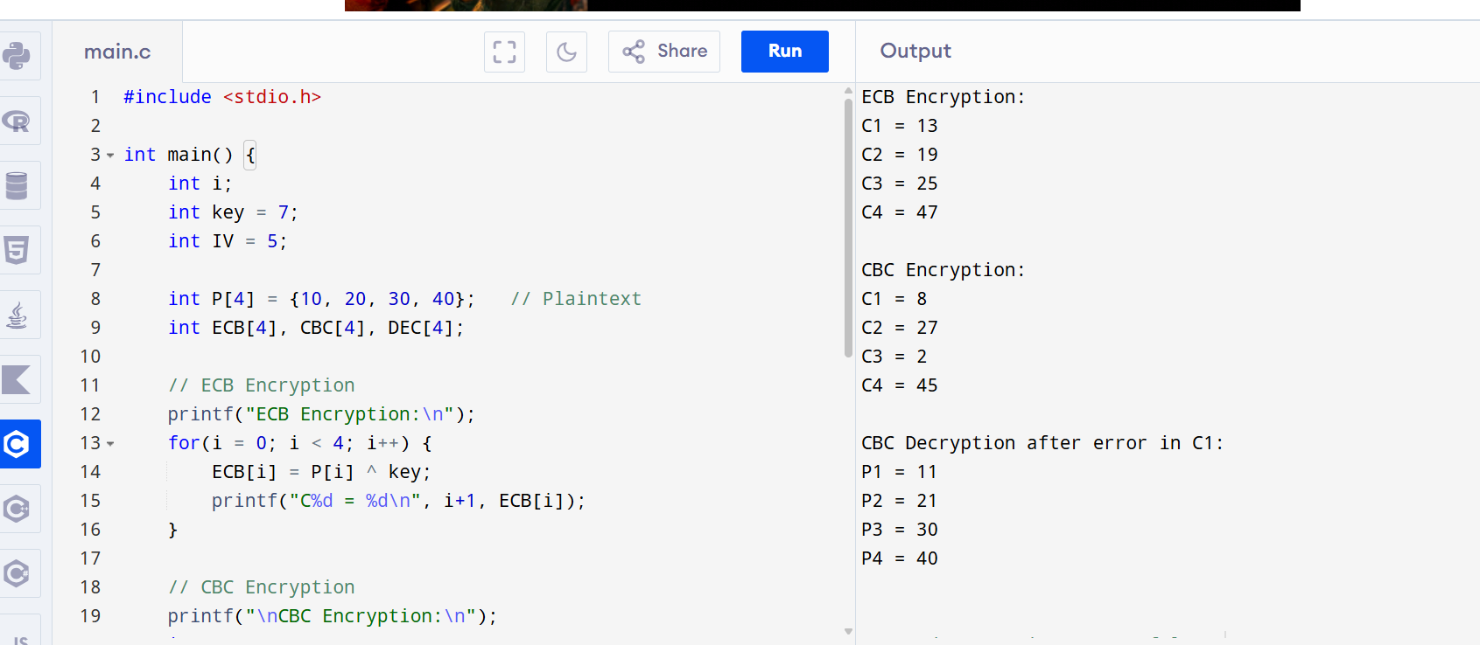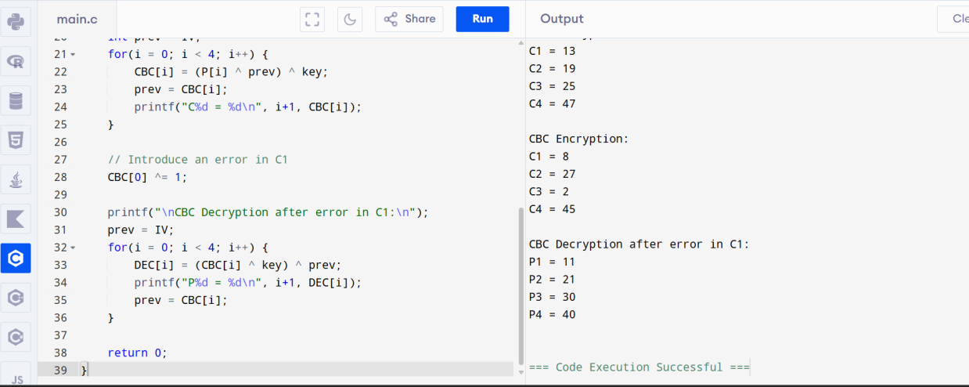
21. Write a C program for ECB, CBC, and CFB modes, the plaintext must be a sequence of one or more
complete data blocks (or, for CFB mode, data segments). In other words, for these three modes, the total
number of bits in the plaintext must be a positive multiple of the block (or segment) size. One common
method of padding, if needed, consists of a 1 bit followed by as few zero bits, possibly none, as are
necessary to complete the final block. It is considered good practice for the sender to pad every message,
including messages in which the final message block is already complete. What is the motivation for
including a padding block when padding is not needed?
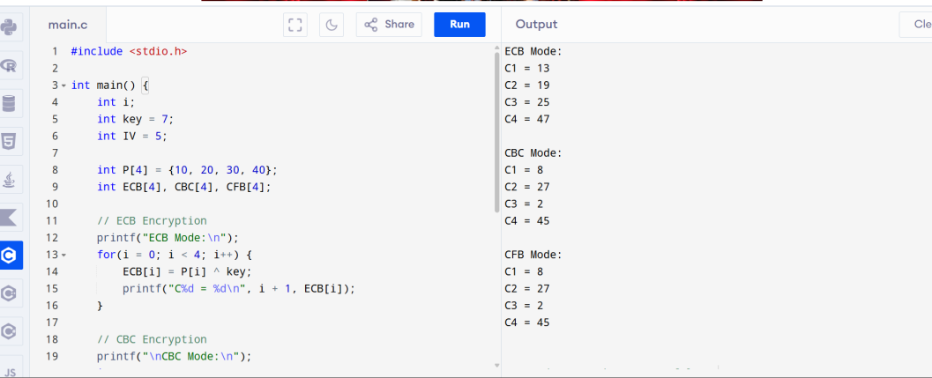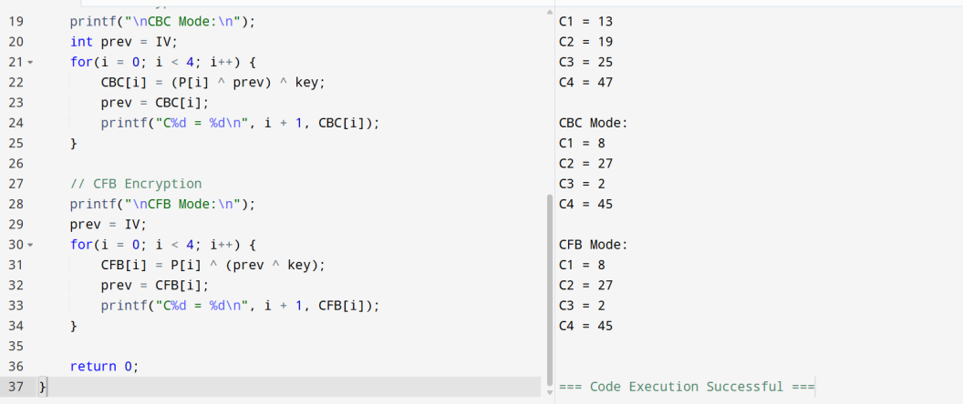
22. Write a C program for Encrypt and decrypt in cipher block chaining mode using one of the following
ciphers: affine modulo 256, Hill modulo 256, S-DES, DES. Test data for S-DES using a binary
initialization vector of 1010 1010. A binary plaintext of 0000 0001 0010 0011 encrypted with a binary
key of 01111 11101 should give a binary plaintext of 1111 0100 0000 1011. Decryption should work
correspondingly.
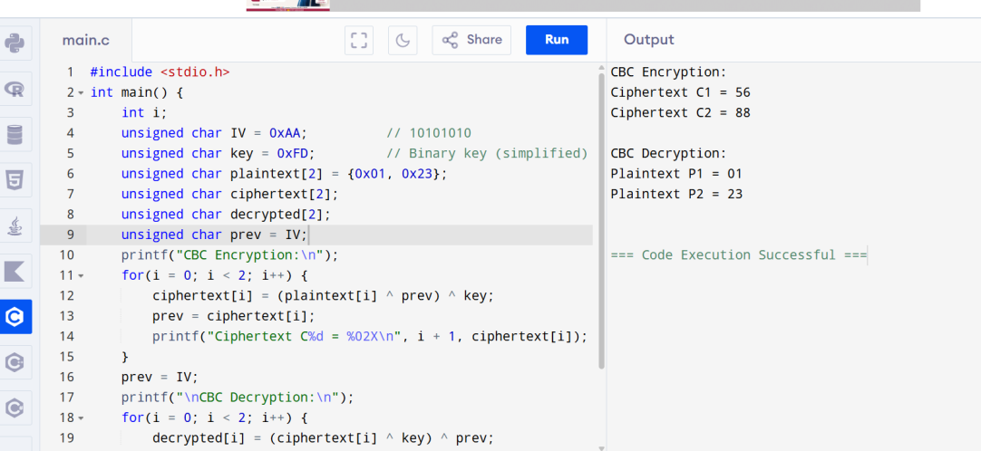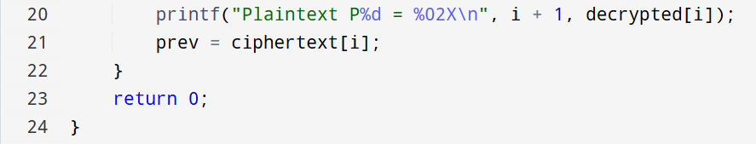
23. Write a C program for Encrypt and decrypt in counter mode using one of the following ciphers:
affine modulo 256, Hill modulo 256, S-DES. Test data for S-DES using a counter starting at 0000 0000.
A binary plaintext of 0000 0001 0000 0010 0000 0100 encrypted with a binary key of 01111 11101
should give a binary plaintext of 0011 1000 0100 1111 0011 0010. Decryption should work
correspondingly.
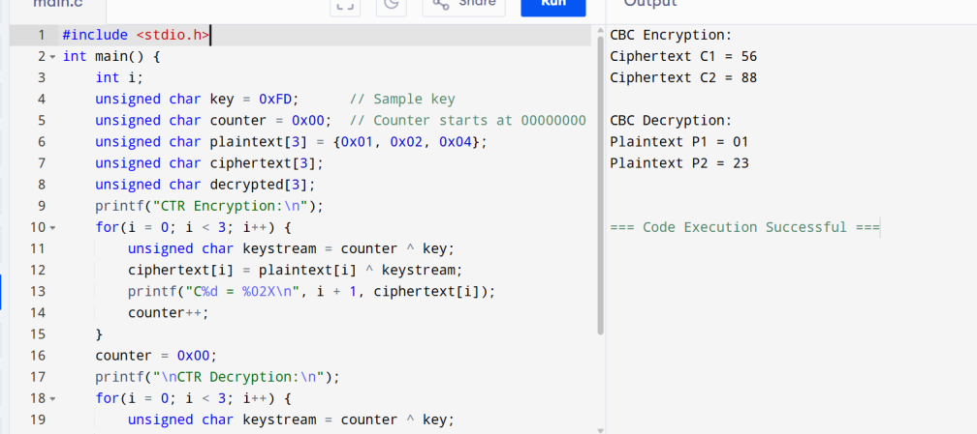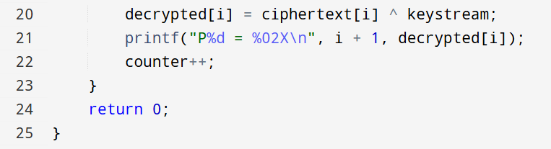
24. Write a C program for RSA system, the public key of a given user is e = 31, n = 3599. What is the
private key of this user? Hint: First use trial-and-error to determine p and q; then use the extended
Euclidean algorithm to find the multiplicative inverse of 31 modulo f(n).
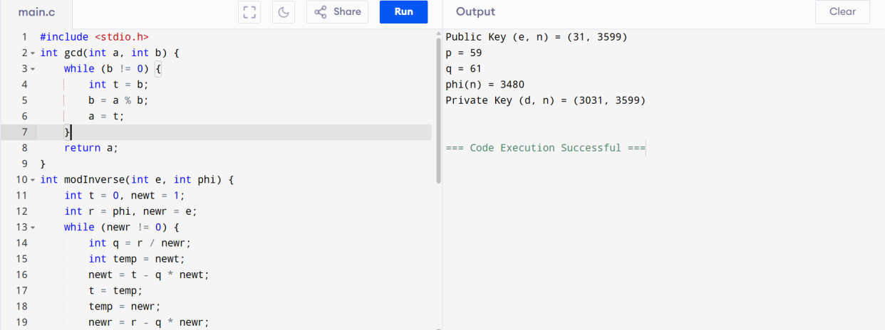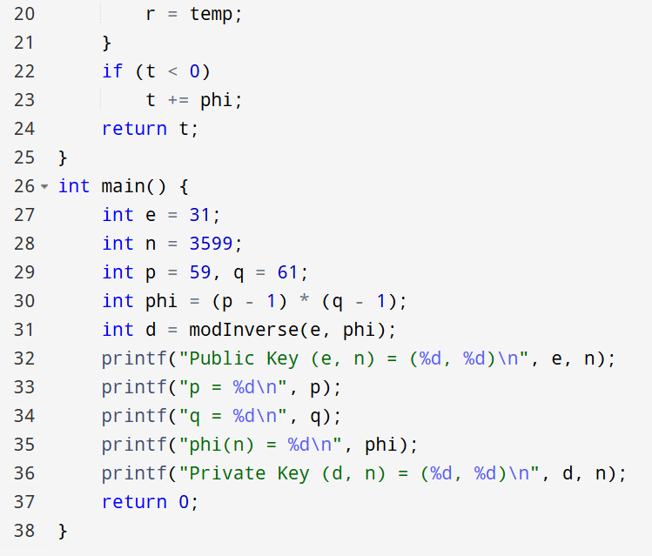
25. Write a C program for set of blocks encoded with the RSA algorithm and we don’t have the private
key. Assume n = pq, e is the public key. Suppose also someone tells us they know one of the plaintext
blocks has a common factor with n. Does this help us in any way?
